Software Development Unit 3, 3.5

Anna Legaspi

# I can adjust settings so that others can access IT tools and devices for collaborative working

For this unit, I’ve created a collaborative file in Google docs which can be found in the link below. Please access the document to see how we’ve collaborated in this file.

<https://docs.google.com/document/d/1UCYIu4U2e8eK--2qGPUyiFjPHMBPfoDEJHRGPaA4EdU/edit?usp=sharing>

## Things I’ve considered to make this file collaborative:

1. I created the file and set it up so that anyone with a link can access and edit the file.

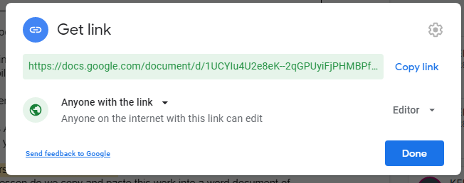

1. Multiple co-learners were able to access the file and note their name on the table I’ve created.

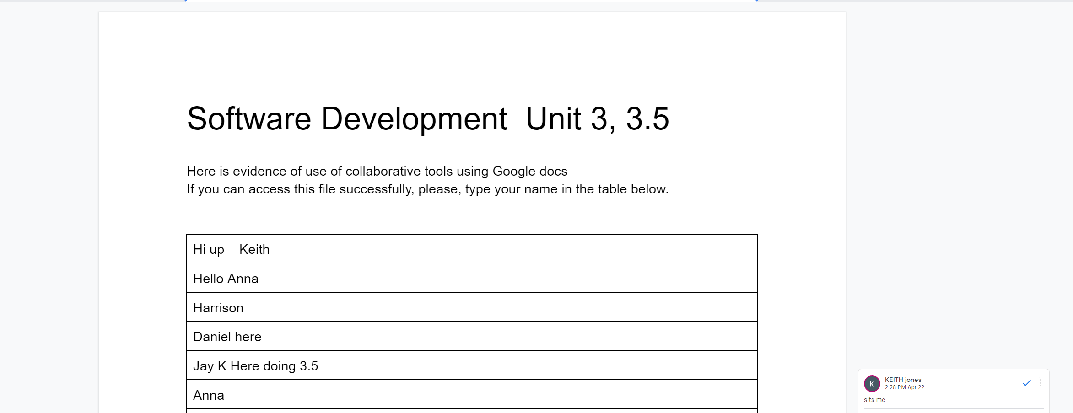

1. My tutor had issues accessing the file since Google drive is restricted in his work PC, so I invited him to access the file from his personal device and I can send the link a different way. I emailed him the link via another email address he owns and he was able to access and put an input on the file.

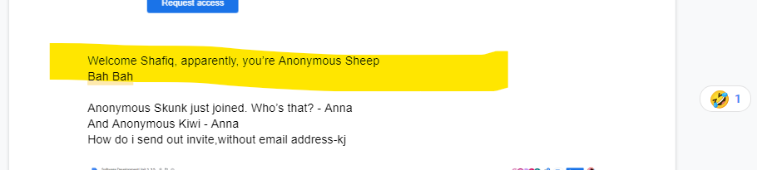

1. I’ve asked my co-learners if they can access the accessibility tools and they confirmed on the file itself that they have. This will help others who have trouble reading or seeing the words on the file

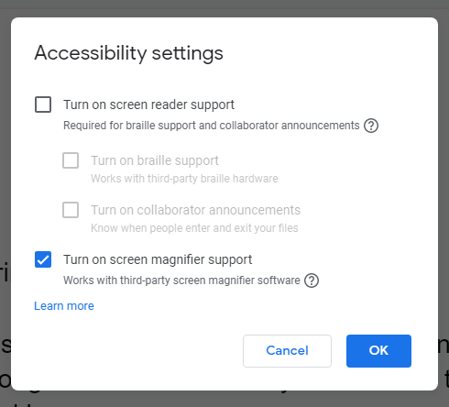

1. I can personally use shortcuts like Ctrl+ and Ctrl- to adjust the website for my own viewing.

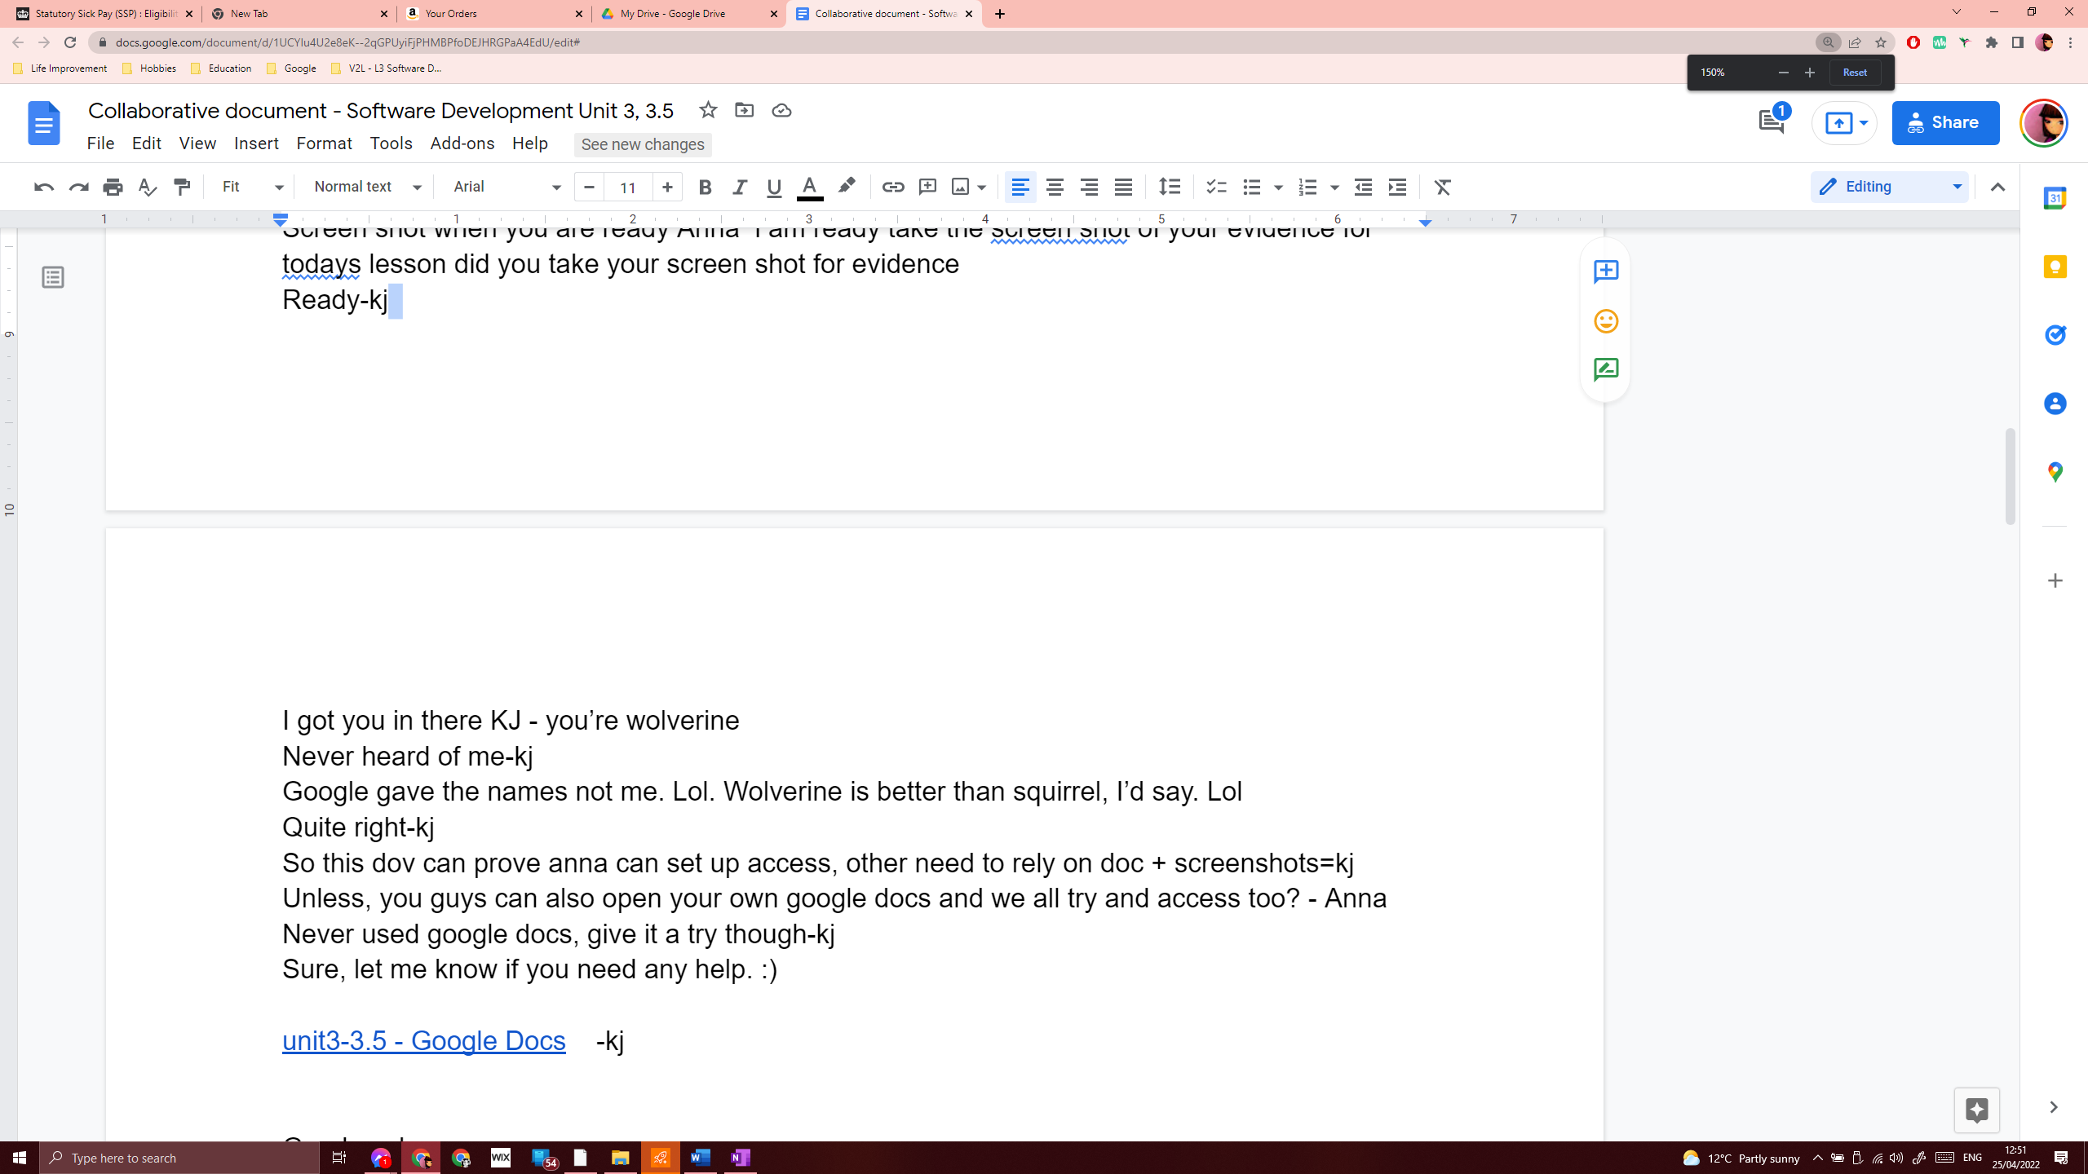



Even better, Google docs already have their own settings to adjust the view.

